SIMATS ENGINEERING
Department of Computer Science and Engineering

CSA15 Cloud Computing and Big Data Analytics
CO3 AT1 - Guided Cloud Access Experiments Workbook

Course Outcome | CO3 - Implement cloud-based solutions using cloud storage, web APIs, and platform services for real-world applications.
Unit Alignment | Unit 3 - Access to Cloud: cloud access, platforms, web applications, APIs, storage models, SAN, serverless, edge/fog, collaboration, security and development workflow.
Faculty | Dr C. Rajesh Babu, Professor, Department of CSE
Employee ID | SSETSCS415
Submission Mode | Individual PDF evidence through Google Classroom and GitHub repository link.

How This Workbook Works
Stage | Student Action
Learn | Read the short technical note before touching the tool.
Do | Perform the guided action using the recommended tool.
Observe | Check what changed on the screen or in the output.
Record | Paste screenshots, URLs, tables, command outputs or diagram references.
Explain | Write the technical reasoning in your own words.
Extend | Apply the same concept to the capstone product continued from CO2 AT3.
Submit | Upload the completed evidence to GitHub and Google Classroom.

Important Safety Rule
Screenshots must not reveal passwords, private keys, API tokens, payment details, personal account recovery information or sensitive user data. Crop or mask sensitive values before submission.

Student and Faculty Details
Student Name | M Deepika | Register Number | 192311027

Class / Section | BE CSE | Slot | B
Course | CSA15 Cloud Computing and Big Data Analytics | Assessment | CO3 AT1
Capstone Title | Cloud-Based Medicine Inventory Management System | Submission Date
Faculty | Dr C. Rajesh Babu | Employee ID | SSETSCS415
Department | Computer Science and Engineering | GitHub Link

Tool Links
Tool | Purpose | Link
Firebase Console | Cloud storage and project evidence | https://console.firebase.google.com/
Postman | REST API request-response evidence | https://www.postman.com/downloads/
JSONPlaceholder | Safe public API for GET/POST practice | https://jsonplaceholder.typicode.com/
ReqRes | Safe public API for request-response practice | https://reqres.in/
draw.io | Architecture and workflow diagrams | https://app.diagrams.net/
GitHub | Repository evidence submission | https://github.com/
GitHub Pages | Simple hosted web access evidence | https://pages.github.com/

Experiment 1: Cloud Storage Model Comparison and Selection
Original CO3 Question | Create and document a cloud storage comparison between object, block, and file storage. Select the best storage model for backups, VM disks, and shared enterprise documents.
Tools | Firebase Console, Firebase Storage, draw.io, browser, GitHub.
CO2 AT3 Continuity | Use the same capstone title and infrastructure direction already defended in CO2 AT3. Do not repeat VM sizing; focus on cloud service access.

Learn
A cloud application may store files, database records, VM disks, images, logs and shared documents. Object storage,



block storage and file storage solve different workload problems. Firebase Storage is used here as a beginner-friendly object storage console because students can create a project, open a storage bucket, upload a file, observe metadata and reason about access control from the browser.

Do
- Begin in the browser at https://console.firebase.google.com/. Sign in with the account approved for academic work. After the console opens, use Add project or Create a project. Give the project a course-friendly name such as csa15-co3-regno. If Google Analytics is shown, keep it disabled unless faculty instructs otherwise. Create the project and wait until the project dashboard opens. The screen to notice is the Firebase project overview page.
- In the left navigation area, open Build and choose Storage. If Storage is not yet enabled, choose the option to get started. Select the default bucket location shown by Firebase or the nearest available region. Use test access only for lab observation if the console requires an initial rule choice, and remember that production apps must use strict authenticated rules. The screen to notice is the storage bucket page.
- Create a small text file on the computer named student_backup.txt. Add two lines inside it: the student register number and the capstone title. Return to Firebase Storage and use Upload file. Select student_backup.txt and wait until it appears in the bucket list. The screen to notice is the object list showing the uploaded file.
- Open the uploaded file entry. Observe the metadata area: file name, file size, content type, storage path, creation/update time and access status. If a download URL or access token is visible, do not paste sensitive token values in the workbook. Record only the safe evidence: filename, type, size and storage path.
- Open draw.io and draw a three-part comparison diagram: object storage for uploaded files/backups, block storage for VM disks, and file storage for shared folders. Under the diagram, write where your capstone will use storage and why Firebase Storage represents object storage in this experiment.

Observe
Check whether the uploaded file is visible, whether metadata is displayed, and whether public/private access is controlled. Do not expose sensitive files.

Record Evidence
Evidence Item | Student Reference / Screenshot Number | Checkpoint
Cloud storage dashboard screenshot. | Screenshot 1 | [ ] Completed
Uploaded object/file screenshot. | Screenshot 2 | [ ] Completed
Metadata screenshot. | Screenshot 3 | [ ] Completed
Completed storage model comparison table. | Table 1 | [ ] Completed
Capstone storage recommendation table. | Table 2 | [ ] Completed

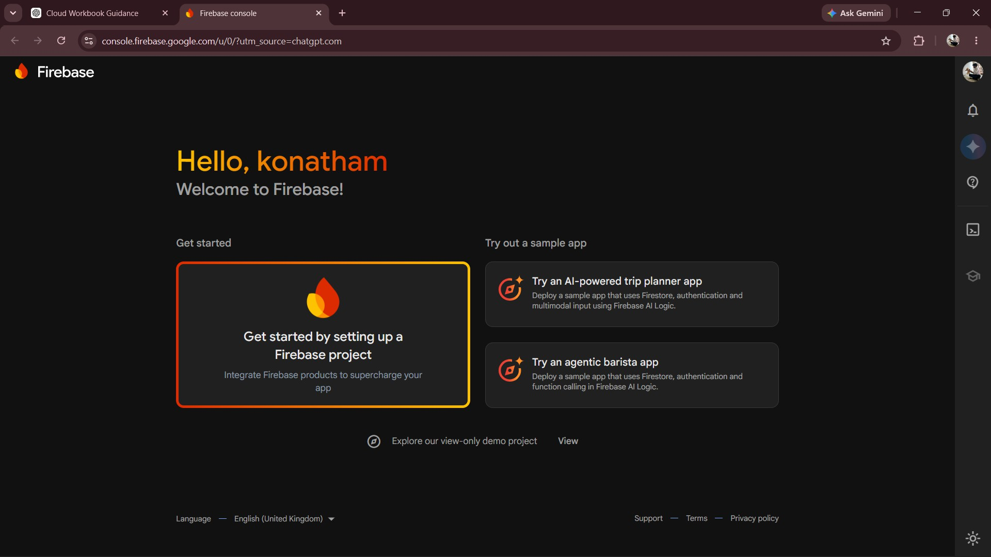
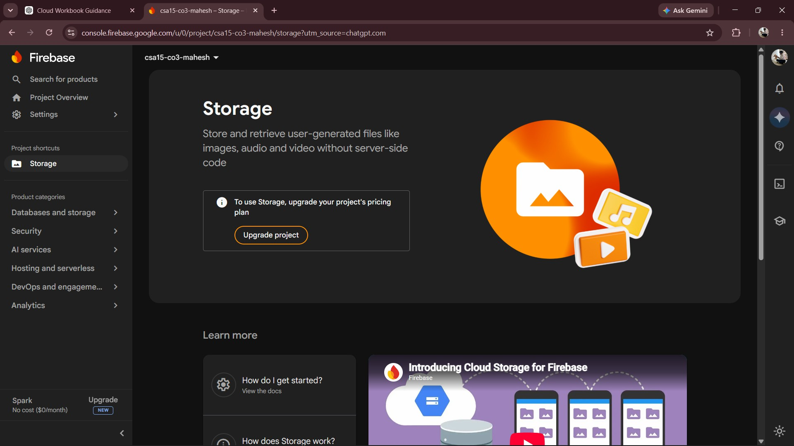

Explain
Why is one storage model not suitable for all workloads? Justify using backup, VM disk and shared-folder examples, then extend the answer to your capstone product.
Student Explanation Space
One storage model is not suitable for all workloads because each type of data has different requirements for access, performance and sharing. Object storage is suitable for medicine images, backup files, reports and other unstructured data because it provides scalable cloud storage. Block storage is suitable for virtual machine disks because it provides fast and direct access to stored data. File storage is suitable for documents that must be shared among hospital or pharmacy staff using a folder-based structure. In the Cloud-Based Medicine Inventory Management System, object storage can be used for backups and uploaded files, while the database stores structured medicine inventory information. Therefore, selecting the appropriate storage model improves performance, scalability and reliability.

Extend to Capstone
Select the storage model required for your capstone product: user uploads, app images, database attachments, logs, backups or shared documents.

Capstone Title | SafeWalk – Cloud Route Intelligence Using Crowd Reports and Risk Heatmaps
CO2 AT3 Infrastructure Decision Carried Forward | The capstone uses cloud-based infrastructure for storing, processing and accessing crowd reports, route information and risk heatmap data.
Cloud Service / Access Layer Added in this Experiment | Firebase Storage is used as the cloud object-storage layer for crowd-report data, route-related files, risk heatmaps and application files.
Risk or Limitation Identified | ncorrect storage access rules may expose crowd reports, route data or risk-related files to unauthorized users.
Improvement for Prototype or Pilot | Use authenticated access, secure Firebase Storage rules and separate storage locations for raw crowd reports, processed route data and risk heatmap files.

Submit
GitHub Folder | CO3_AT1/Experiment_1
Files to Upload | Completed PDF, diagrams, screenshots and any exported table.
Google Classroom Entry | Paste GitHub repository link and attach final PDF.

Experiment 2: REST API Workflow for a Cloud-Based Student Portal
Original CO3 Question | Develop a simple REST API workflow for a cloud-based student portal. Show request, response, authentication,

 | and deployment flow.
Tools | Postman Web/Desktop, JSONPlaceholder or ReqRes, draw.io, browser, GitHub.
CO2 AT3 Continuity | Use the same capstone title and infrastructure direction already defended in CO2 AT3. Do not repeat VM sizing; focus on cloud service access.

Learn
REST API means Representational State Transfer Application Programming Interface. For beginners, think of it as a controlled doorway through which a client app asks a cloud service for data or sends data to be processed. A browser or mobile app sends a request to an API endpoint. The API validates the request, applies business logic, communicates with storage or database services, and returns a structured response. Postman is used because it lets students send requests, view status codes, inspect headers, read JSON responses and test API behavior without writing a full app first.

Do
- Open https://www.postman.com/ or the Postman desktop application. Sign in or create a free account if Postman asks for one. After the workspace opens, create a personal workspace or use the default workspace. Create a collection named CSA15_CO3_AT1_API so the evidence is organized.
- Open a new request tab. Keep the method as GET. Enter https://jsonplaceholder.typicode.com/users in the request URL field and send the request. Look at the response area. The expected observation is a successful status such as 200 OK and a JSON response containing user-like records.
- Read one object from the JSON response. Identify fields such as id, name, username, email, address and company. Record three fields in the workbook and explain what each field would mean in a student portal or capstone product.
- Create another request with method POST. Use https://jsonplaceholder.typicode.com/posts as the URL. Open the Body area, choose raw, select JSON, and enter a small JSON body such as {"title":"CSA15 cloud test","body":"API evidence","userId":1}. Send the request. The expected observation is a created/test response, often with status 201 or a simulated response.
- Open draw.io and draw the request-response flow. Show Browser/Mobile Client -> REST API Endpoint -> Backend Logic -> Database/Storage -> JSON Response. Add a small authentication gate before backend logic to show that real cloud applications should protect API access.

Observe
Verify whether the request returns status 200 or a valid test response. Identify JSON fields and explain what each field represents.

Record Evidence
Evidence Item | Student Reference / Screenshot Number | Checkpoint
Postman GET request screenshot. | Screenshot 4 | [ ] Completed
Status code and response time screenshot. | Screenshot 5 | [ ] Completed
JSON field identification table. | Table 3 | [ ] Completed
POST request body and response | Screenshot 6 | [ ] Completed

screenshot.
API workflow diagram. | Figure 1 | [ ] Completed
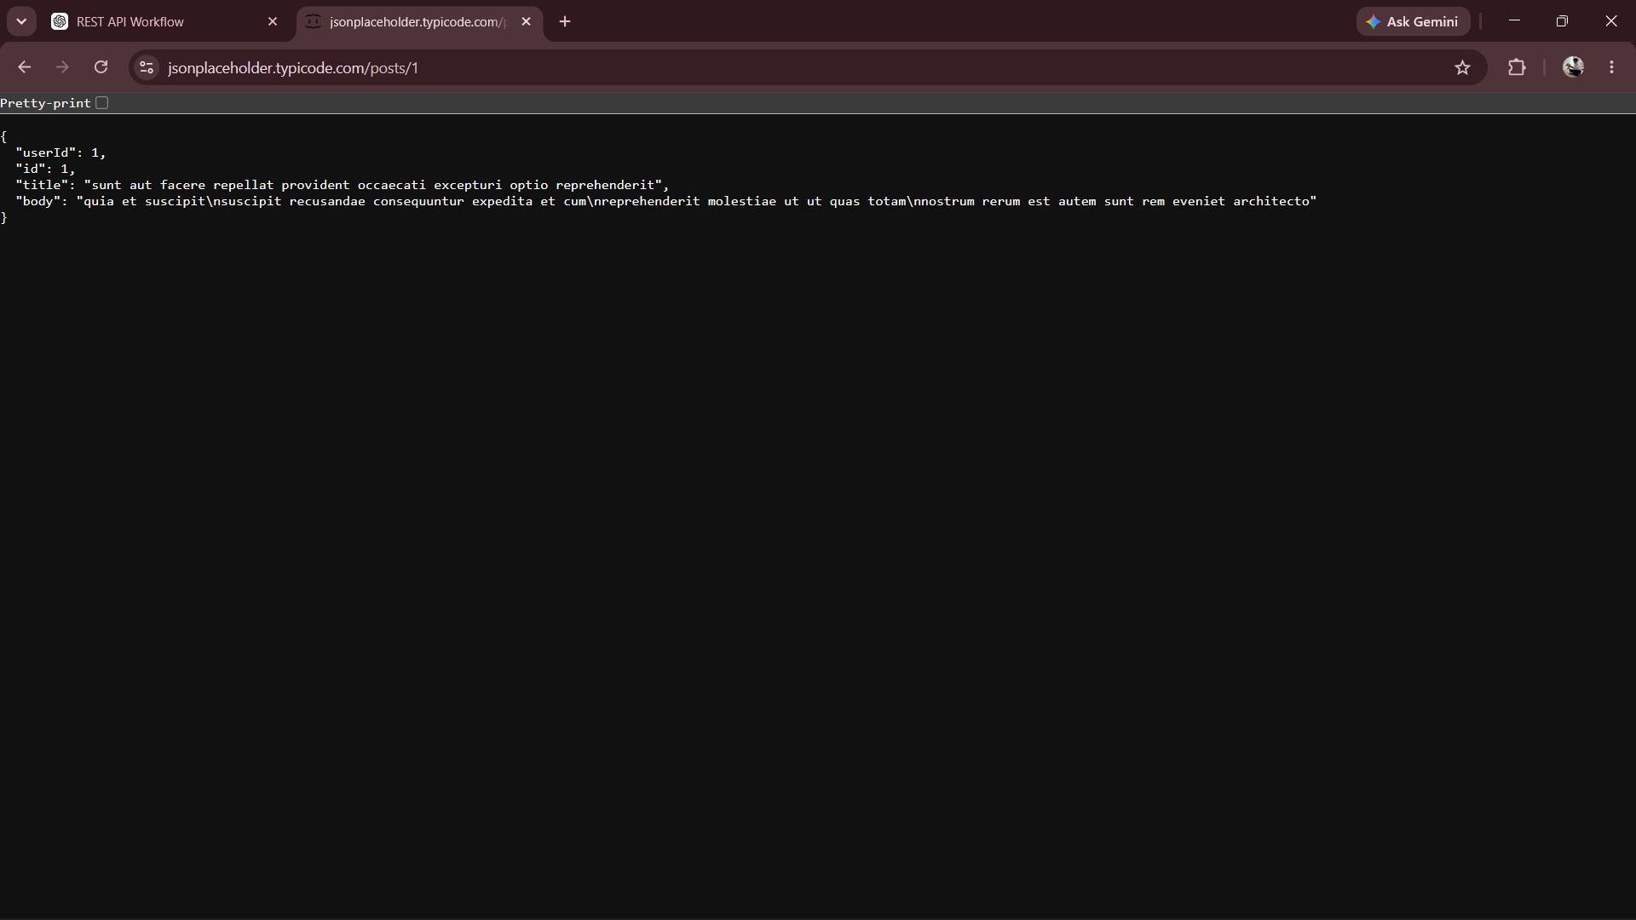

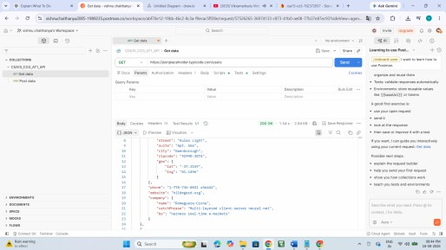

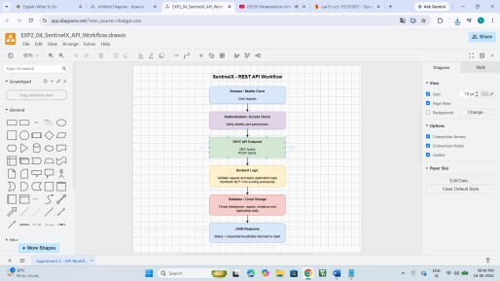

Explain
Why should a cloud application expose data through APIs instead of allowing users to directly access the database?
Student Explanation Space
A cloud application should expose data through APIs instead of allowing users to directly access the database because APIs provide a controlled and secure communication layer. The API can authenticate users, validate requests and restrict the operations that each user is allowed to perform. It also hides the internal database structure from clients and prevents unauthorized modification of data. In the Medicine Inventory Management System, the frontend can use GET requests to retrieve medicine stock information and POST requests to add or update inventory records. The API processes the request, communicates with the cloud database and returns a structured JSON response. This approach improves security, maintainability and scalability.

Extend to Capstone
Write two API endpoints for your capstone product and explain the input, backend action, storage access and response.

Capstone Title | SafeWalk – Cloud Route Intelligence Using Crowd Reports and Risk Heatmaps
CO2 AT3 Infrastructure Decision Carried Forward | The capstone uses cloud-based infrastructure to securely  access and manage crowd reports, route information and risk heatmap data through an API layer.
Cloud Service / Access Layer Added in this Experiment | A REST API access layer is added to provide controlled communication between the SafeWalk application and the cloud storage/database.

Risk or Limitation Identified | The API retrieves crowd reports and route risk data through GET requests and accepts new crowd reports through POST requests.
Improvement for Prototype or Pilot | Incorrect API authentication or validation may allow unauthorized users to access or submit incorrect SafeWalk data.

Submit
GitHub Folder | CO3_AT1/Experiment_2
Files to Upload | Completed PDF, diagrams, screenshots and any exported table.
Google Classroom Entry | Paste GitHub repository link and attach final PDF.

Experiment 3: Serverless Event Flow for Image Upload Processing
Original CO3 Question | Design a serverless event flow for image upload processing using object storage, function-as-a-service, and notification service.
Tools | draw.io, Firebase Storage evidence from Experiment 1, optional Pipedream/Make simulation, GitHub.
CO2 AT3 Continuity | Use the same capstone title and infrastructure direction already defended in CO2 AT3. Do not repeat VM sizing; focus on cloud service access.

Learn
Serverless computing allows a cloud platform to run code in response to events without the student managing the server directly. In this experiment, students do not need paid cloud function deployment. They design and document a correct event-driven flow. The key idea is: an event happens, a cloud function is triggered, the function performs a small task, and another cloud service records or sends the output.

Do
- Start with the uploaded file evidence from Experiment 1. Treat the upload as the event. For capstone mapping, choose one event such as image upload, booking creation, complaint submission, attendance scan, payment update or alert generation.
- In the workbook, write the event source in a short table. Mention who performs the action, what data is created, where it is stored, and what should happen automatically after the event.
- Design the cloud function behavior without writing production code. Name the function clearly, for example processUploadedImage, confirmBooking, validateAttendance or sendIssueAlert. Write what the function receives, what it checks, what it changes, and what output it produces.
- Decide the output service. It may be a notification, email, database status update, dashboard row, resized image, log entry or report update. Also decide what should happen if the function fails: retry, error log, faculty/admin alert or manual review.

- Draw the event flow in draw.io using this visual order: User Action -> Cloud Storage/Database Event -> Serverless Function -> Processing Decision -> Output Service -> Log/Monitoring. Paste the diagram and complete the trigger-action-output table.

Observe
Identify the trigger, processing function, output service, failure point and retry/alert requirement. If billing blocks real function deployment, submit a technically accurate simulation and architecture evidence.

Record Evidence
Evidence Item | Student Reference / Screenshot Number | Checkpoint
Event source evidence or simulated event table. | Table 4 | [ ] Completed
Serverless flow diagram. | Figure 2 | [ ] Completed
Trigger-action-output table. | Table 5 | [ ] Completed
Failure and retry note. | Note 1 | [ ] Completed
Capstone event mapping. | Table 6 | [ ] Completed

Explain
Why is serverless suitable for upload/event processing? Mention one limitation also.

Student Explanation Space
Serverless computing is suitable for event and upload processing because functions can automatically execute whenever a specific cloud event occurs. There is no need to continuously manage or maintain a dedicated server. For example, when a medicine record or inventory file is uploaded, a serverless function can validate the information, update the database, generate a stock status and send an alert if required. Serverless services can automatically scale according to the number of events and can reduce infrastructure management. One limitation is that serverless functions may experience execution delays such as cold starts and may also have execution-time or platform limitations.

Extend to Capstone
Apply the serverless idea to one real capstone workflow, such as image processing, booking confirmation, attendance validation, alert generation or report update.

Capstone Title | SafeWalk – Cloud Route Intelligence Using Crowd Reports and Risk Heatmaps
CO2 AT3 Infrastructure Decision Carried Forward | The capstone uses cloud-based infrastructure for storing, processing and accessing crowd reports, route information and risk heatmap data.
Cloud Service / Access Layer Added in this Experiment

 | Firebase Firestore is added as the cloud database layer for storing and accessing SafeWalk crowd reports, route information and risk-related data.
Risk or Limitation Identified | Incomplete or inaccurate crowd reports may produce incorrect risk levels and affect the reliability of route recommendations.
Improvement for Prototype or Pilot | Use data validation, secure Firestore rules and automated risk-scoring methods to improve the accuracy and reliability of SafeWalk.

Submit
GitHub Folder | CO3_AT1/Experiment_3
Files to Upload | Completed PDF, diagrams, screenshots and any exported table.
Google Classroom Entry | Paste GitHub repository link and attach final PDF.

Experiment 4: Edge and Fog Computing for Smart Traffic Management
Original CO3 Question | Compare edge computing and fog computing for a smart traffic management system. Include architecture, latency considerations, and deployment location.
Tools | draw.io, Google Sheets or Excel latency table, optional Wokwi/IoT screenshot only if faculty permits, GitHub.
CO2 AT3 Continuity | Use the same capstone title and infrastructure direction already defended in CO2 AT3. Do not repeat VM sizing; focus on cloud service access.

Learn
Cloud computing is powerful but may be physically distant from sensors and users. Edge computing places small decisions very near the data source. Fog computing introduces an intermediate distributed layer between edge devices and the central cloud. This experiment is an architecture reasoning activity; students are not required to build a real traffic sensor. The correct output is a placement decision supported by latency and data-volume reasoning.

Do
- Use this scenario: traffic cameras and road sensors produce vehicle count, speed, congestion level and emergency vehicle alerts. Some actions must happen immediately at the signal, some can be handled at a regional traffic control unit, and some can be stored in the central cloud for analysis.

- Classify each task into edge, fog or cloud. Put instant signal switching and emergency alert detection near edge. Put junction-level aggregation and area coordination in fog. Put long-term storage, analytics dashboard and city-level reports in cloud.
- Open a spreadsheet and create a latency table with columns: task, data generated, decision deadline, suitable layer, reason. Use example decision deadlines such as 1 second for emergency signal response, 5-10 seconds for regional coordination and minutes/hours for reports. The exact numbers are reasoning aids, not measured network results.
- Draw the architecture in draw.io. Show sensors/cameras at the road, edge device at signal controller, fog node at regional traffic control, cloud platform for storage/analytics and dashboard for administrator. Use arrows to show data movement and labels to show why each layer is used.
- Connect the same idea to the capstone. If the capstone has live location, sensor, mobile offline, queue, emergency, QR attendance or fast alert behavior, identify what can be edge/fog/cloud. If the capstone does not need edge/fog, state that browser/mobile client -> cloud service access is sufficient and justify it.

Observe
Check whether time-critical actions are placed closer to data sources and whether long-term storage/analytics remain in the cloud.

Record Evidence
Evidence Item | Student Reference / Screenshot Number | Checkpoint
Task classification table. | Table 7 | [ ] Completed
Latency reasoning table. | Table 8 | [ ] Completed
Edge-fog-cloud architecture diagram. | Figure 3 | [ ] Completed
Deployment location justification. | Note 2 | [ ] Completed
Capstone relevance note. | Note 3 | [ ] Completed

Explain
Which part of the system should run at edge, fog and cloud? Justify with latency and data-volume reasoning.

Student Explanation Space
Edge computing should handle operations that require an immediate response because processing occurs close to the source of data. In a smart traffic system, emergency vehicle detection and instant signal switching can be performed at the edge to minimize latency. Fog computing can aggregate information from several nearby junctions and coordinate regional traffic decisions within a few seconds. Cloud computing is suitable for large-scale storage, historical analysis, dashboards and reports because these operations do not require an immediate response and may process large volumes of data. Therefore, edge reduces latency, fog provides intermediate coordination and cloud provides scalable storage and analytics.

Extend to Capstone
If your capstone has location-sensitive, sensor-based, offline-first or fast-alert requirements, identify the edge/fog/cloud placement. If not applicable, justify why direct cloud access is sufficient.

Capstone Title | SafeWalk – Cloud Route Intelligence Using Crowd Reports  and Risk Heatmaps
CO2 AT3 Infrastructure Decision Carried Forward | The capstone uses cloud-based infrastructure for storing and processing crowd reports and route information to support location-based risk analysis.
Cloud Service / Access Layer Added in this Experiment | Cloud-based data processing is added to analyse crowd  reports and generate risk levels and heatmap information for different locations.
Risk or Limitation Identified | Limited or outdated crowd reports may result in inaccurate risk levels and unreliable risk heatmaps.
Improvement for Prototype or Pilot | Use regular data updates, improved risk-scoring logic and validation of crowd reports to generate more reliable risk heatmaps.

Submit
GitHub Folder | CO3_AT1/Experiment_4
Files to Upload | Completed PDF, diagrams, screenshots and any exported table.
Google Classroom Entry | Paste GitHub repository link and attach final PDF.

Experiment 5: Cloud Application Deployment and Access Workflow
Original CO3 Question | Demonstrate a cloud application deployment workflow showing client access, browser interaction, web API call, storage access, and monitoring.
Tools | GitHub Pages as primary beginner path, Firebase Hosting as optional path, Postman, draw.io, GitHub repository, browser.
CO2 AT3 Continuity | Use the same capstone title and infrastructure direction already defended in CO2 AT3. Do not repeat VM sizing; focus on cloud service access.

Learn
A cloud-backed application is accessed through a browser or mobile client. The user action travels through frontend, API/backend, authentication, platform services, storage/database and monitoring/logging components. GitHub Pages is the primary beginner path because it can host a simple static page from a repository. Firebase Hosting may be used



when the student is comfortable with Firebase CLI or Cloud Shell.

Do
- Create or open a GitHub repository for CO3 AT1. Add a simple index.html file. The page should show the capstone title, one user action and one cloud service used. Example page sections: product name, user action, API endpoint idea, storage used and evidence link.
- In the repository settings, open Pages. Select the main branch and root folder as the publishing source when available. Save the Pages setting and wait for GitHub to publish the site. Open the generated Pages URL in the browser and verify that the page loads.
- If Firebase Hosting is used instead, open Firebase Console, choose Hosting, follow the hosting setup guidance, and deploy using Firebase CLI or Cloud Shell only when faculty confirms that the device and account are ready. For most beginners, GitHub Pages evidence is sufficient for this experiment.
- Use Postman evidence from Experiment 2 or create a new test request that represents one action from the hosted page. Example: the user clicks Submit Complaint, the frontend sends POST /reports, the backend stores the complaint image path and returns a status response.
- Draw the complete access workflow in draw.io: Browser/Mobile Client -> Hosted Frontend -> API Endpoint -> Authentication Check -> Backend/Serverless Logic -> Cloud Storage/Database -> Response -> Monitoring/Log. Paste the hosted URL, browser screenshot, workflow diagram and GitHub repository link.

Observe
Verify whether the hosted page or simulated access URL opens, whether the API/storage flow is technically consistent, and whether monitoring/logging evidence is identified.

Record Evidence
Evidence Item | Student Reference / Screenshot Number | Checkpoint
Hosted page URL or approved simulation evidence. | Evidence 1 | [ ] Completed
Browser access screenshot. | Screenshot 7 | [ ] Completed
API/storage workflow diagram. | Figure 4 | [ ] Completed
Monitoring/logging metric table. | Table 9 | [ ] Completed
GitHub repository link. | Evidence 2 | [ ] Completed

Explain
Explain the complete request flow from client action to cloud output and monitoring.

Student Explanation Space
The complete cloud request flow begins when a user accesses the Medicine Inventory Management System through a browser or mobile application. The hosted frontend displays the application interface and sends the user's request to a REST API endpoint. The authentication layer verifies whether the user is authorized before allowing the request to reach the backend. The backend validates the input and performs the required business logic. It then reads or writes medicine information in the cloud database or storage service. The processed result is returned through the API to the frontend and displayed to the user. Important operations, errors and response information are recorded using monitoring and logging so that administrators can identify failures and maintain system reliability.



Extend to Capstone
Extend the workflow to the capstone product carried forward from CO2 AT3, showing how the planned infrastructure now exposes usable cloud services.

Capstone Title | SafeWalk – Cloud Route Intelligence Using Crowd Reports  and Risk Heatmaps
CO2 AT3 Infrastructure Decision Carried Forward | The capstone uses cloud-based infrastructure and an API access layer to provide secure access to crowd reports, route information and risk data.
Cloud Service / Access Layer Added in this Experiment | A REST API access layer is added to connect the SafeWalk application with Firebase Firestore for retrieving existing reports and storing new crowd reports.
Risk or Limitation Identified | Unauthorized API access, incorrect data and network failures may affect the security and reliability of the SafeWalk application.
Improvement for Prototype or Pilot | Implement API authentication, input validation, secure database rules, error handling and logging for reliable production use.

Submit
GitHub Folder | CO3_AT1/Experiment_5
Files to Upload | Completed PDF, diagrams, screenshots and any exported table.
Google Classroom Entry | Paste GitHub repository link and attach final PDF.

Final Submission Checklist
Checklist Item | Status
Experiment 1 completed with storage model evidence | [ ]
Experiment 2 completed with API evidence | [ ]
Experiment 3 completed with serverless/event-flow | [ ]



evidence
Experiment 4 completed with edge/fog/cloud reasoning | [ ]
Experiment 5 completed with cloud application access workflow | [ ]
All diagrams exported and pasted | [ ]
All screenshots are readable and privacy-safe | [ ]
Capstone extension completed for every experiment | [ ]
GitHub folder created and link added | [ ]
Google Classroom submission completed | [ ]

Student Assurance
Declaration | I confirm that this CO3 AT1 guided experiment workbook contains my own cloud access evidence, diagrams, observations, explanations and capstone extensions. I have not shared private credentials or sensitive information.
Student Signature | M Deepika
Faculty Verification
Date

